**Exercise -1 : Create a Spring Web Project using Maven**

***Filename :*** *SpringLearnApplication.java*

package com.cognizant.springlearn;

import org.springframework.boot.SpringApplication;

import org.springframework.boot.autoconfigure.SpringBootApplication;

@SpringBootApplication

public class SpringLearnApplication {

public static void main(String[] args) {

SpringApplication.*run*(SpringLearnApplication.class, args);

System.*out*.println("Application Started!");

}

}

**Filename:** Application.properties

spring.application.name=spring-learn

server.port=8081

**Filename :** pom.xml (Modified the exixting file)

<groupId>com.cognizant</groupId>

<artifactId>spring-learn</artifactId>

<version>0.0.1-SNAPSHOT</version>

<dependencies>

<dependency>

<groupId>org.springframework.boot</groupId>

<artifactId>spring-boot-starter-web</artifactId>

</dependency>

<dependency>

<groupId>org.springframework.boot</groupId>

<artifactId>spring-boot-devtools</artifactId>

<scope>runtime</scope>

</dependency>

</dependencies>

**OUTPUT SCREENSHOTS:**

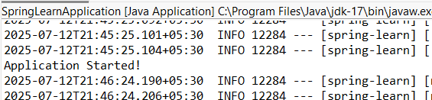

**Exercise – 2 : Spring Core – Load Country from Spring Configuration XML.**

**Filename :** *SpringLearnApplication.java*

package com.cognizant.springlearn;

import org.slf4j.Logger;

import org.slf4j.LoggerFactory;

import org.springframework.context.ApplicationContext;

import org.springframework.context.support.ClassPathXmlApplicationContext;

public class SpringLearnApplication {

private static final Logger *LOGGER* =

LoggerFactory.*getLogger*(SpringLearnApplication.class);

public static void main(String[] args) {

*LOGGER*.debug("Inside main()");

*displayCountry*(); // Load and display the country bean

}

public static void displayCountry() {

ApplicationContext context = new

ClassPathXmlApplicationContext("country.xml");

Country country = context.getBean("country", Country.class);

*LOGGER*.debug("Country : {}", country.toString());

System.*out*.println("Country: " + country);

}

}

**Filename :** *SpringLearnApplication.java*

package com.cognizant.springlearn;

import org.slf4j.Logger;

import org.slf4j.LoggerFactory;

public class Country {

private static final Logger *LOGGER* = LoggerFactory.*getLogger*(Country.class);

private String code;

private String name;

public Country() {

*LOGGER*.debug("Inside Country Constructor.");

}

public String getCode() {

*LOGGER*.debug("Inside getCode()");

return code;

}

public void setCode(String code) {

*LOGGER*.debug("Inside setCode()");

this.code = code;

}

public String getName() {

*LOGGER*.debug("Inside getName()");

return name;

}

public void setName(String name) {

*LOGGER*.debug("Inside setName()");

this.name = name;

}

@Override

public String toString() {

return "Country [code=" + code + ", name=" + name + "]";

}

}

**OUTPUT SCREENSHOTS :**

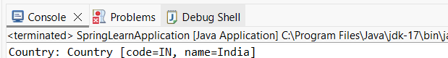

**Exercise – 3 - Hello World RESTful Web Service**

**Filename :** *SpringLearnApplication.java*

package com.cognizant.springlearn;

import org.slf4j.Logger;

import org.slf4j.LoggerFactory;

import org.springframework.boot.SpringApplication;

import org.springframework.boot.autoconfigure.SpringBootApplication;

@SpringBootApplication

public class SpringLearnApplication {

private static final Logger *LOGGER* = LoggerFactory.*getLogger*(SpringLearnApplication.class);

public static void main(String[] args) {

*LOGGER*.debug("Inside main()");

SpringApplication.*run*(SpringLearnApplication.class, args);

}

}

**Filename :** *pom.xml(modified-added dependency)*

*<dependency>*

*<groupId>org.springframework.boot</groupId>*

*<artifactId>spring-boot-starter-test</artifactId>*

*<scope>test</scope>*

*</dependency>*

**Filename :** *application.properties*

*server.port=8083*

**Filename :** *HelloController.java*

package com.cognizant.springlearn.Controller;

import org.slf4j.Logger;

import org.slf4j.LoggerFactory;

import org.springframework.web.bind.annotation.GetMapping;

import org.springframework.web.bind.annotation.RestController;

@RestController

public class HelloController {

private static final Logger *LOGGER* = LoggerFactory.*getLogger*(HelloController.class);

@GetMapping("/hello")

public String sayHello() {

*LOGGER*.info("START sayHello()");

String message = "Hello World!!";

*LOGGER*.info("END sayHello()");

return message;

}

}

**OUTPUT SCREENSHOTS :**

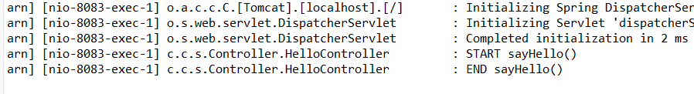

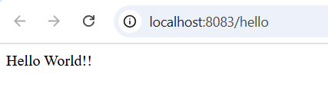

**Exercise – 4- REST - Country Web Service**

**Filename :** *SpringLearnApplication.java*

package com.cognizant.springlearn;

import org.springframework.boot.SpringApplication;

import org.springframework.boot.autoconfigure.SpringBootApplication;

@SpringBootApplication

public class SpringLearnApplication {

public static void main(String[] args) {

SpringApplication.run(SpringLearnApplication.class, args);

}

}

**Filename :** *application.properties*

server.port=8083

spring.jackson.serialization.indent_output=true

**Filename :** *Country.java*

package com.cognizant.springlearn;

public class Country {

private String code;

private String name;

public Country() {}

public String getCode() {

return code;

}

public void setCode(String code) {

this.code = code;

}

public String getName() {

return name;

}

public void setName(String name) {

this.name = name;

}

@Override

public String toString() {

return "Country [code=" + code + ", name=" + name + "]";

}

}

**Filename :** *Country.xml*

<?xml version="1.0" encoding="UTF-8"?>

<beans xmlns="http://www.springframework.org/schema/beans"

xmlns:xsi="http://www.w3.org/2001/XMLSchema-instance"

xsi:schemaLocation="

http://www.springframework.org/schema/beans

http://www.springframework.org/schema/beans/spring-beans.xsd">

<bean id="country" class="com.cognizant.springlearn.Country">

<property name="code" value="IN"/>

<property name="name" value="India"/>

</bean>

</beans>

**Filename :** *CountryController.java*

package com.cognizant.springlearn.Controller;

import com.cognizant.springlearn.Country;

import org.slf4j.Logger;

import org.slf4j.LoggerFactory;

import org.springframework.context.ApplicationContext;

import org.springframework.context.support.ClassPathXmlApplicationContext;

import org.springframework.web.bind.annotation.RequestMapping;

import org.springframework.web.bind.annotation.RestController;

@RestController

public class CountryController {

private static final Logger *LOGGER* =

LoggerFactory.*getLogger*(CountryController.class);

@RequestMapping("/country")

public Country getCountryIndia() {

*LOGGER*.info("START getCountryIndia()");

ApplicationContext context = new

ClassPathXmlApplicationContext("country.xml");

Country country = context.getBean("country", Country.class);

*LOGGER*.info("END getCountryIndia()");

return country;

}

}

**OUTPUT SCREENSHOTS :**

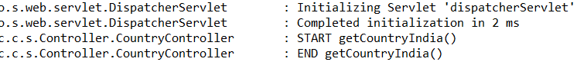

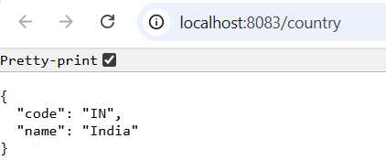

**Exercise – 5 - REST - Get country based on country code**

**Filename :** *Country.xml*

<?xml version="1.0" encoding="UTF-8"?>

<beans xmlns="http://www.springframework.org/schema/beans"

xmlns:xsi="http://www.w3.org/2001/XMLSchema-instance"

xsi:schemaLocation="http://www.springframework.org/schema/beans

http://www.springframework.org/schema/beans/spring-beans.xsd">

<!-- List of countries -->

<bean id="countryList" class="java.util.ArrayList">

<constructor-arg>

<list>

<bean class="com.cognizant.springlearn.Country">

<property name="code" value="IN"/>

<property name="name" value="India"/>

</bean>

<bean class="com.cognizant.springlearn.Country">

<property name="code" value="US"/>

<property name="name" value="United States"/>

</bean>

<bean class="com.cognizant.springlearn.Country">

<property name="code" value="DE"/>

<property name="name" value="Germany"/>

</bean>

<bean class="com.cognizant.springlearn.Country">

<property name="code" value="JP"/>

<property name="name" value="Japan"/>

</bean>

</list>

</constructor-arg>

</bean>

</beans>

**Filename :** *CountryController.java*

package com.cognizant.springlearn.Controller;

import com.cognizant.springlearn.Country;

import com.cognizant.springlearn.Service.CountryService;

import org.springframework.beans.factory.annotation.Autowired;

import org.springframework.web.bind.annotation.*;

@RestController

public class CountryController {

@Autowired

private CountryService countryService;

@GetMapping("/country/{code}")

public Country getCountry(@PathVariable String code) {

return countryService.getCountry(code);

}

}

**Filename :** *CountryService.java*

package com.cognizant.springlearn.Service;

import com.cognizant.springlearn.Country;

import org.springframework.context.ApplicationContext;

import org.springframework.context.support.ClassPathXmlApplicationContext;

import org.springframework.stereotype.Service;

import java.util.List;

@Service

public class CountryService {

public Country getCountry(String code) {

ApplicationContext context = new ClassPathXmlApplicationContext("country.xml");

List<Country> countryList = (List<Country>) context.getBean("countryList");

return countryList.stream()

.filter(c -> c.getCode().equalsIgnoreCase(code))

.findFirst()

.orElse(null);

} }

**Filename:** *Country.java*

package com.cognizant.springlearn;

public class Country {

private String code;

private String name;

public Country() {}

public String getCode() {

return code;

}

public void setCode(String code) {

this.code = code;

}

public String getName() {

return name;

}

public void setName(String name) {

this.name = name;

}

@Override

public String toString() {

return "Country [code=" + code + ", name=" + name + "]";

}

}

**OUTPUT SCREENSHOTS :**

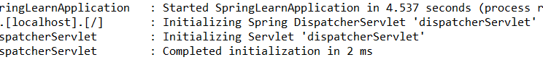

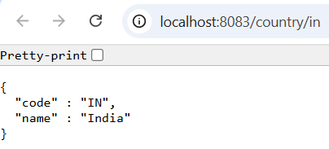

**Execise – 6 - Create authentication service that returns JWT**

**Filename:** SpringLearnAppplication.java

package com.cognizant.springlearn;

import org.springframework.boot.SpringApplication;

import org.springframework.boot.autoconfigure.SpringBootApplication;

@SpringBootApplication

public class SpringLearnApplication {

public static void main(String[] args) {

SpringApplication.*run*(SpringLearnApplication.class, args);

}

}

**Filename:** AuthenticationController.java

package com.cognizant.springlearn.Controller;

import com.cognizant.springlearn.util.JwtUtil;

import org.springframework.beans.factory.annotation.Autowired;

import org.springframework.web.bind.annotation.*;

import jakarta.servlet.http.HttpServletRequest;

import java.util.Base64;

@RestController

public class AuthenticationController {

@Autowired

private JwtUtil jwtUtil;

@GetMapping("/authenticate")

public String generateToken(HttpServletRequest request) {

String authHeader = request.getHeader("Authorization");

if (authHeader != null && authHeader.startsWith("Basic ")) {

// Decode Base64 encoded credentials

String base64Credentials = authHeader.substring("Basic ".length()).trim();

byte[] credDecoded = Base64.*getDecoder*().decode(base64Credentials);

String credentials = new String(credDecoded);

String[] values = credentials.split(":", 2);

String username = values[0];

String password = values[1];

if ("user".equals(username) && "pwd".equals(password)) {

String token = jwtUtil.generateToken(username);

return "{\"token\":\"" + token + "\"}";

}

}

return "{\"error\":\"Invalid credentials\"}";

}

}

**Filename:** application.properties

server.port=8010

**Filename:** jwtUtil.java

package com.cognizant.springlearn.util;

import io.jsonwebtoken.Jwts;

import io.jsonwebtoken.SignatureAlgorithm;

import org.springframework.stereotype.Component;

import java.util.Date;

@Component

public class JwtUtil {

private static final String *SECRET_KEY* = "secret-key";

private static final long *EXPIRATION_TIME* = 60 * 60 * 1000; // 1 hour

public String generateToken(String username) {

return Jwts.*builder*()

.setSubject(username)

.setIssuedAt(new Date(System.*currentTimeMillis*()))

.setExpiration(new Date(System.*currentTimeMillis*() + *EXPIRATION_TIME*))

.signWith(SignatureAlgorithm.*HS256*, *SECRET_KEY*)

.compact();

}

}

**Filename :** *pom.xml(added modification)*

<dependency>

<groupId>org.springframework.boot</groupId>

<artifactId>spring-boot-starter-security</artifactId>

</dependency>

<!-- JWT -->

<dependency>

<groupId>io.jsonwebtoken</groupId>

<artifactId>jjwt</artifactId>

<version>0.9.1</version>

</dependency>

**Filename:** *SecuirityConfig.java*

package com.cognizant.springlearn.config;

import org.springframework.context.annotation.Bean;

import org.springframework.context.annotation.Configuration;

import org.springframework.security.config.annotation.web.configuration.EnableWebSecurity;

import org.springframework.security.web.SecurityFilterChain;

import org.springframework.security.config.annotation.web.builders.HttpSecurity;

@Configuration

@EnableWebSecurity

public class SecurityConfig {

@Bean

public SecurityFilterChain filterChain(HttpSecurity http) throws Exception {

http

.csrf(csrf -> csrf.disable())

.authorizeHttpRequests(auth -> auth

.requestMatchers("/authenticate").permitAll()

.anyRequest().authenticated()

)

.httpBasic(httpBasic -> {});

return http.build();

}

}

**OUTPUT SCREENSHOTS:**

